**PARKS AND RECREATION COMMISSION**

Dave Tuttle, Chair

Mary Shampine

Debbie Martin

Joan Matthews

Randy Robinson

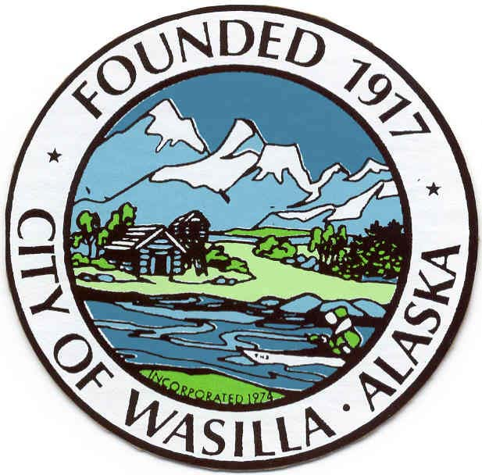

**Parks and Recreation Commission | Regular Meeting Agenda**

**October 12, 2016 | 6 p.m.**

Menard Sports Center | 1001 S. Clapp Street, Wasilla, AK | 907.357.9100

1. **Call to Order**
2. **Roll Call | Determination of a Quorum**
3. **Pledge of Allegiance**
4. **Approval of Agenda**
5. **Approval of Minutes**
   1. September 14, 2016
6. **Staff Reports**
   1. Parks and Recreation Action Log
7. **Public Comments** (3-minutes per person)
8. **Unfinished Business**
   1. Committee of the Whole
      1. Ongoing Projects – Discussion and/or Updates
         1. Public Lands within City Limits
         2. Parks Master Plan-Parks and Recreation Idea list
         3. Volunteer Program
      2. Seasonal Projects and Events
         1. Clean-up Days
         2. 100th Anniversary of the City of Wasilla
         3. Other Special Events
9. **New Business**
10. **Audience Comments** (3-minutes per person)
11. **Staff and Commission Comments**
    1. Next Meeting Date: November 9, 2016 at 6 p.m., Menard Sports Center
12. **Adjournment**